
My Beloved Prabhuji

All credits to you prabhu of completed the deep learning playlist and starting a new course of Generative AI.
I give my full hard work and potential for this subject . I am confident as you are with me. Thanks to you always.

Generative AI
15.06.2025

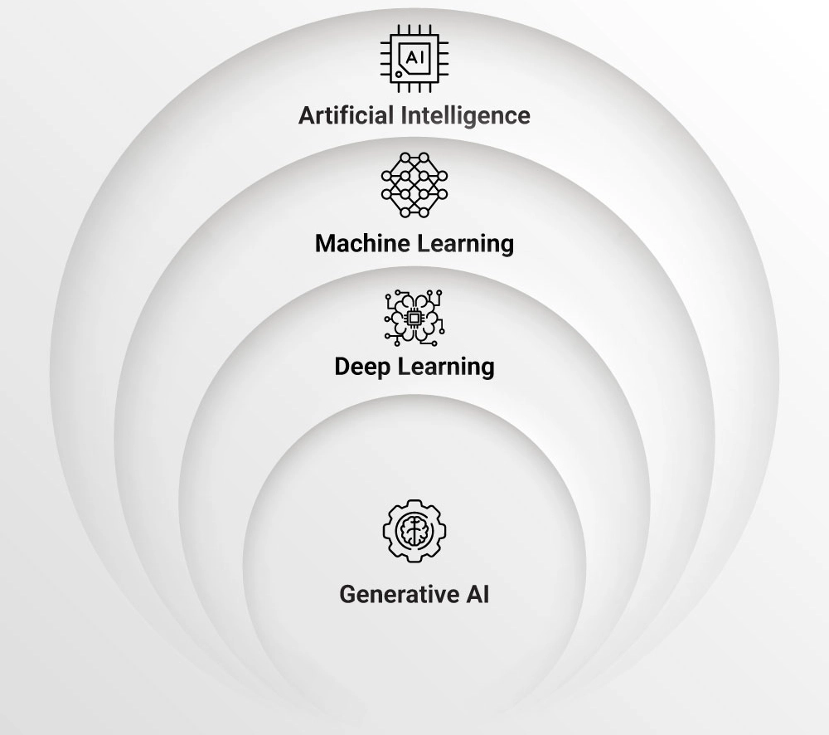
Generative AI (GenAI) is a type of artificial intelligence that creates new content, such as text, images, videos, music, and even code, based on patterns learned from vast datasets mimicking human creativity.
- Solve real world problems
- Impact the world Economics
- Creating new jobs
- Accessible

We have two types of perspectives to study GenAI
- User perspective - where we use LLMs
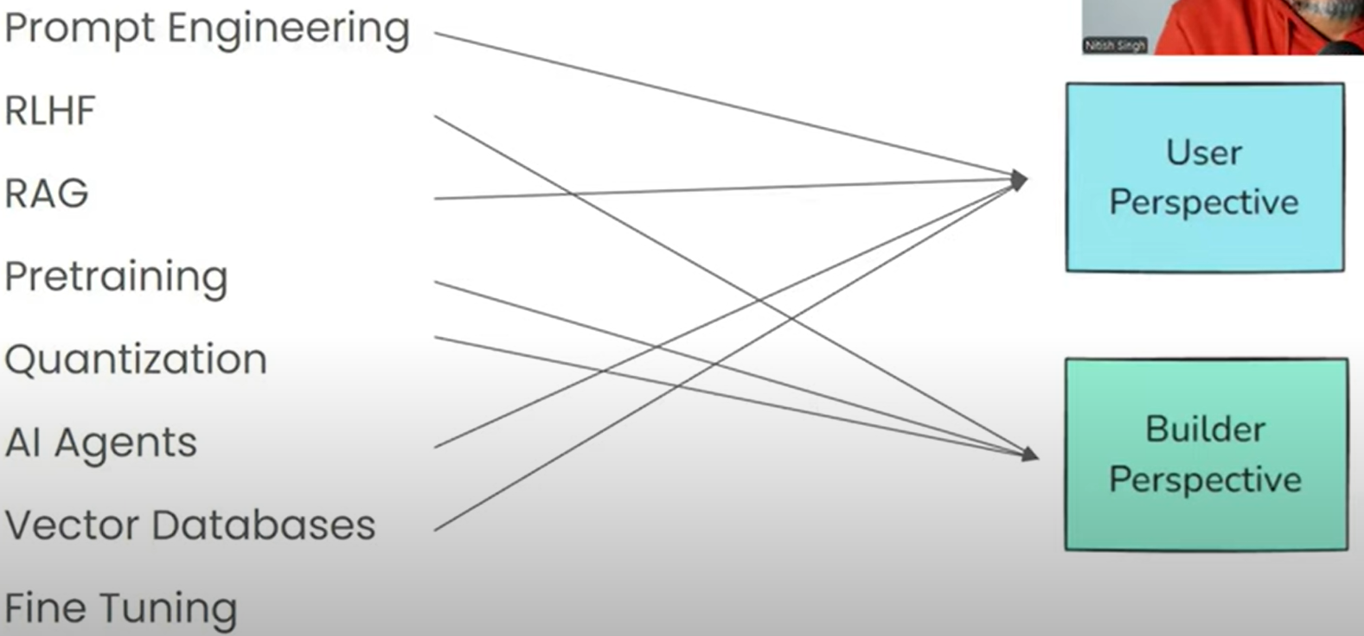
- Builder perspective - where we build LLMs.

LangChain
LangChain is a powerful framework designed to make working with Large Language Models (LLMs) more efficient and scalable. LangChain enables you to build advanced AI applications by integrating Large Language Models (LLMs) with external tools, databases, and workflows.
- Create AI-powered Chatbots
- Enhance AI Memory Context
- Automate AI workflows (chain multiple AI tasks)
- Integrate AI with External tools (APIs , databases)
- Build AI Agents
- Use vector databases for AI search (Semantic search and knowledge retrieval)

LangChain Components
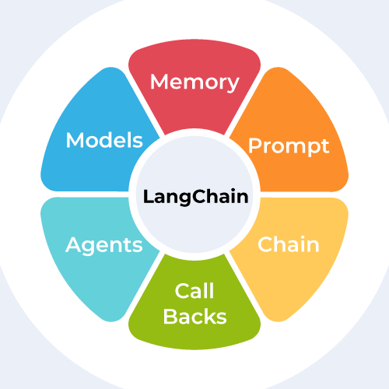call backs is basically “INDEXES”.
We will study each component one by one.

